1. Rest API Untuk Register  
   Endpoint /user-register  
     
   Request Success  
   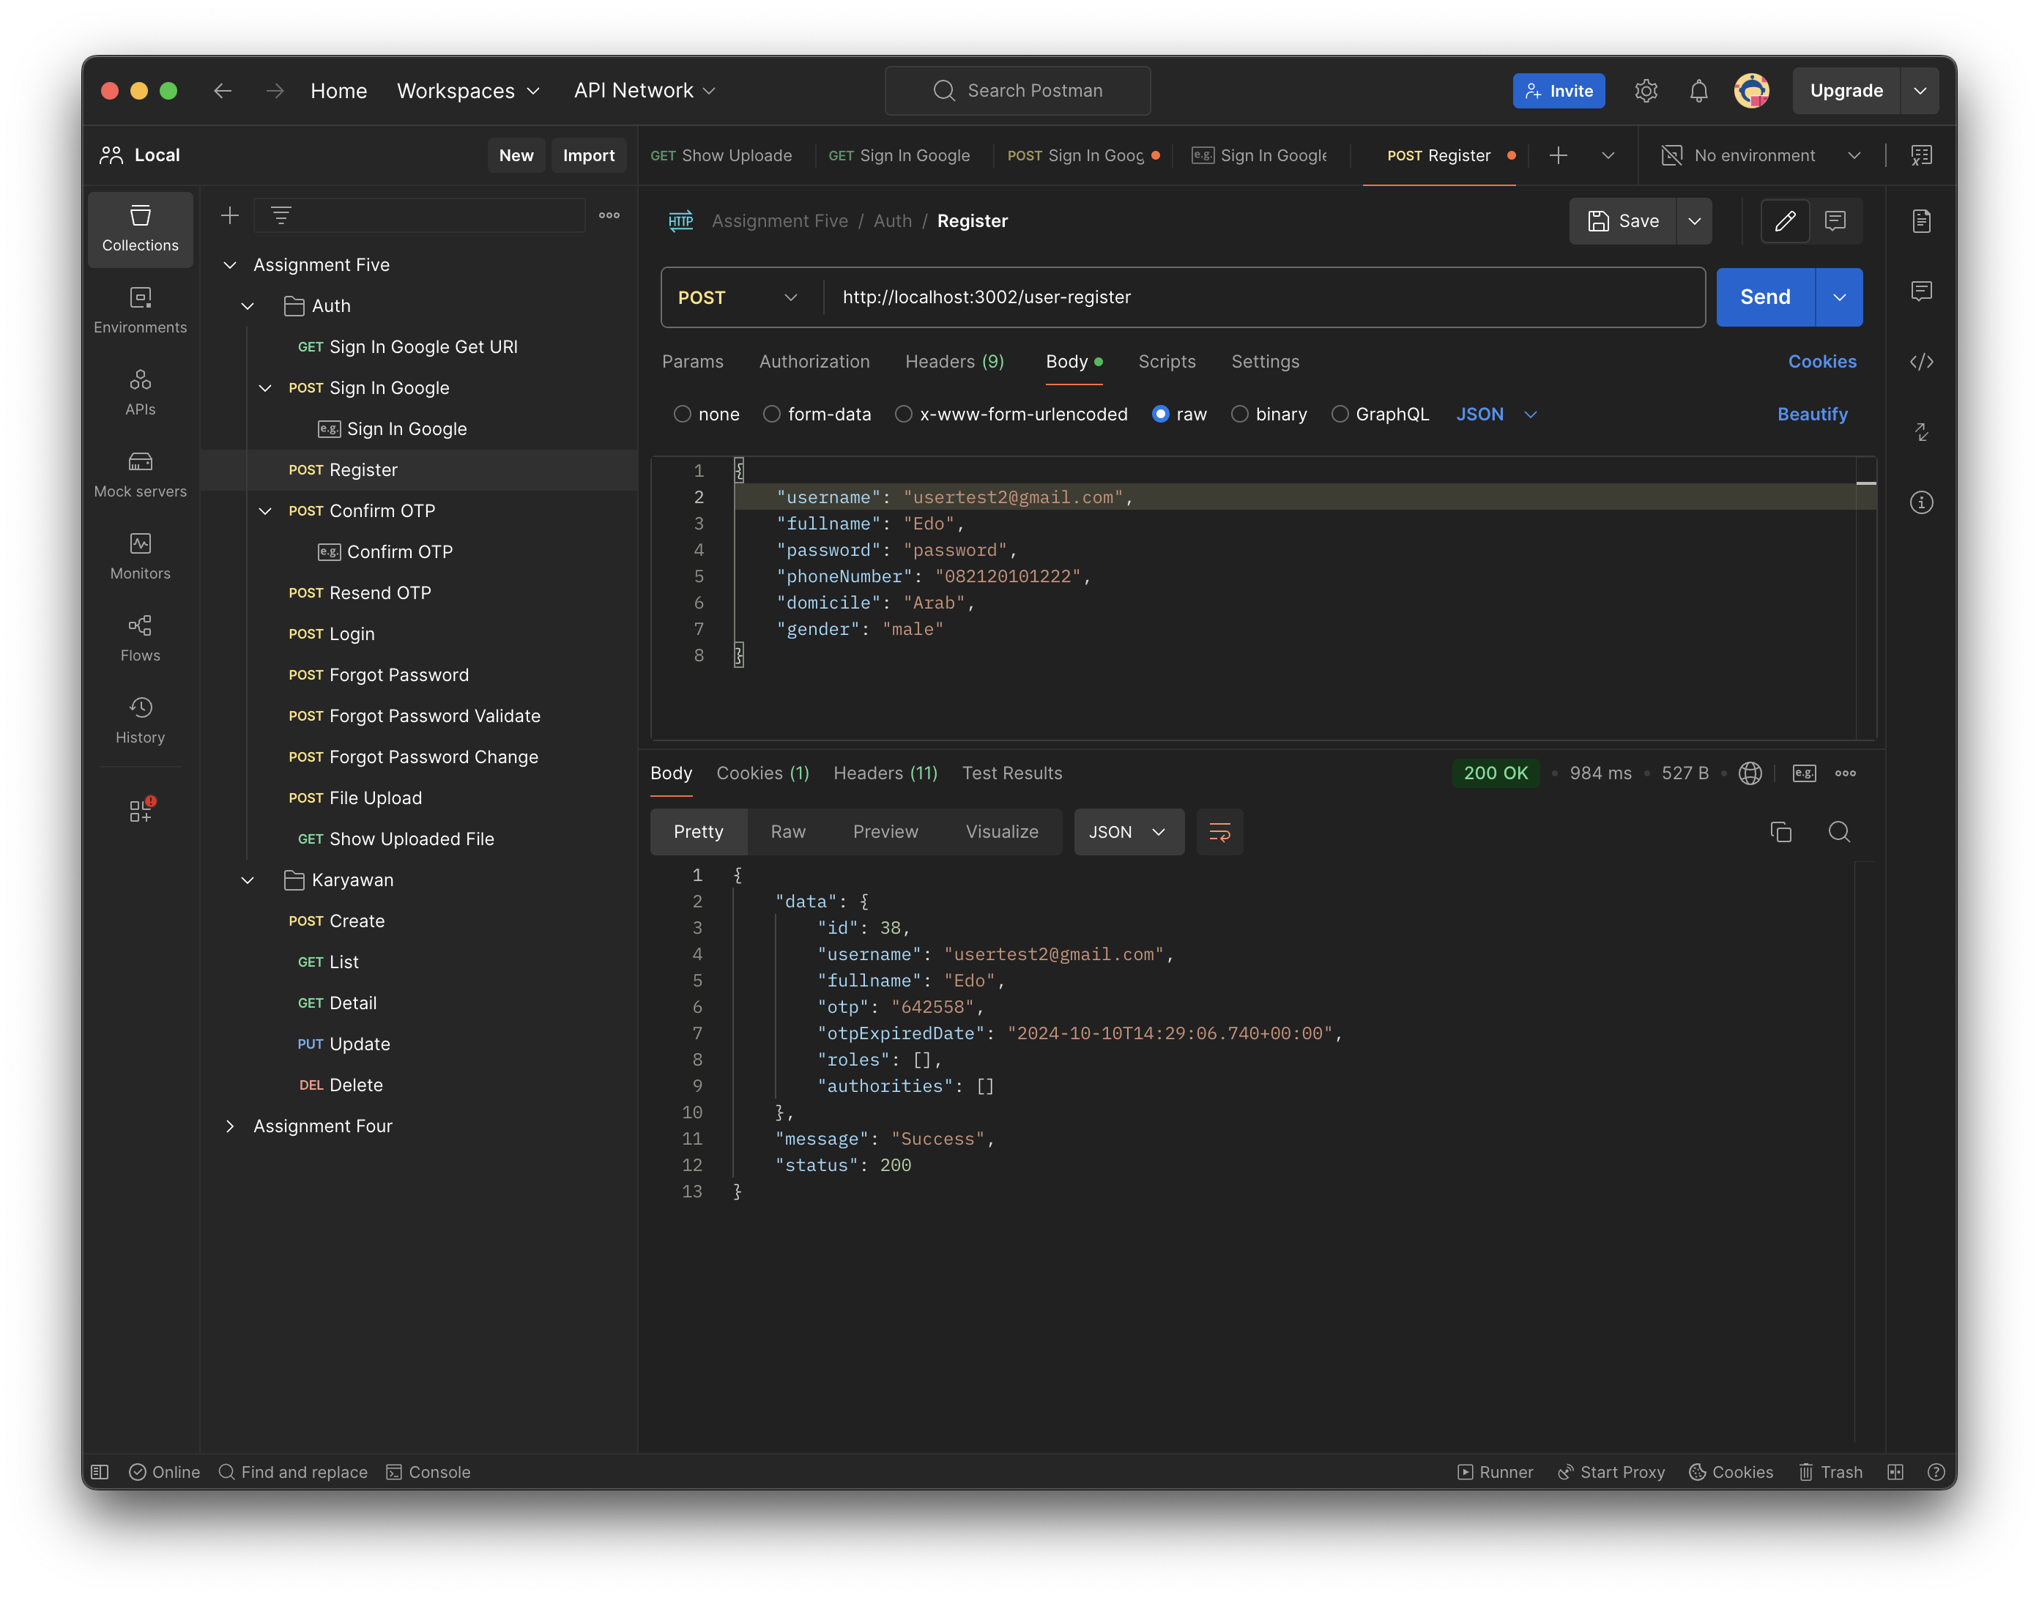  
   Request Failed Username already exists  
   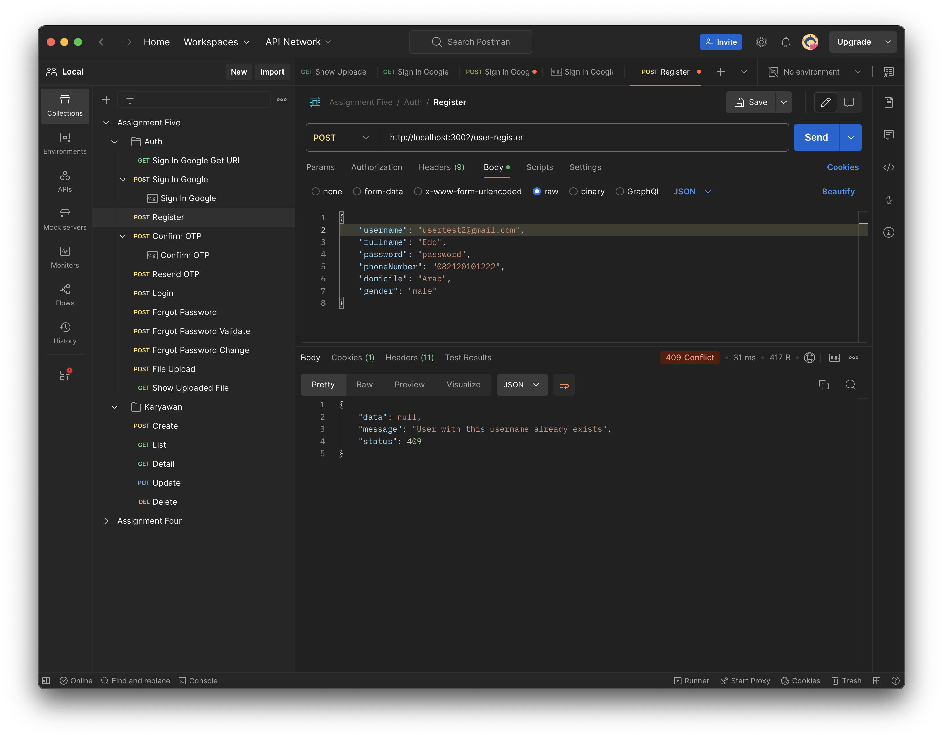
   1. Send OTP Email  
      Endpoint /send-otp  
      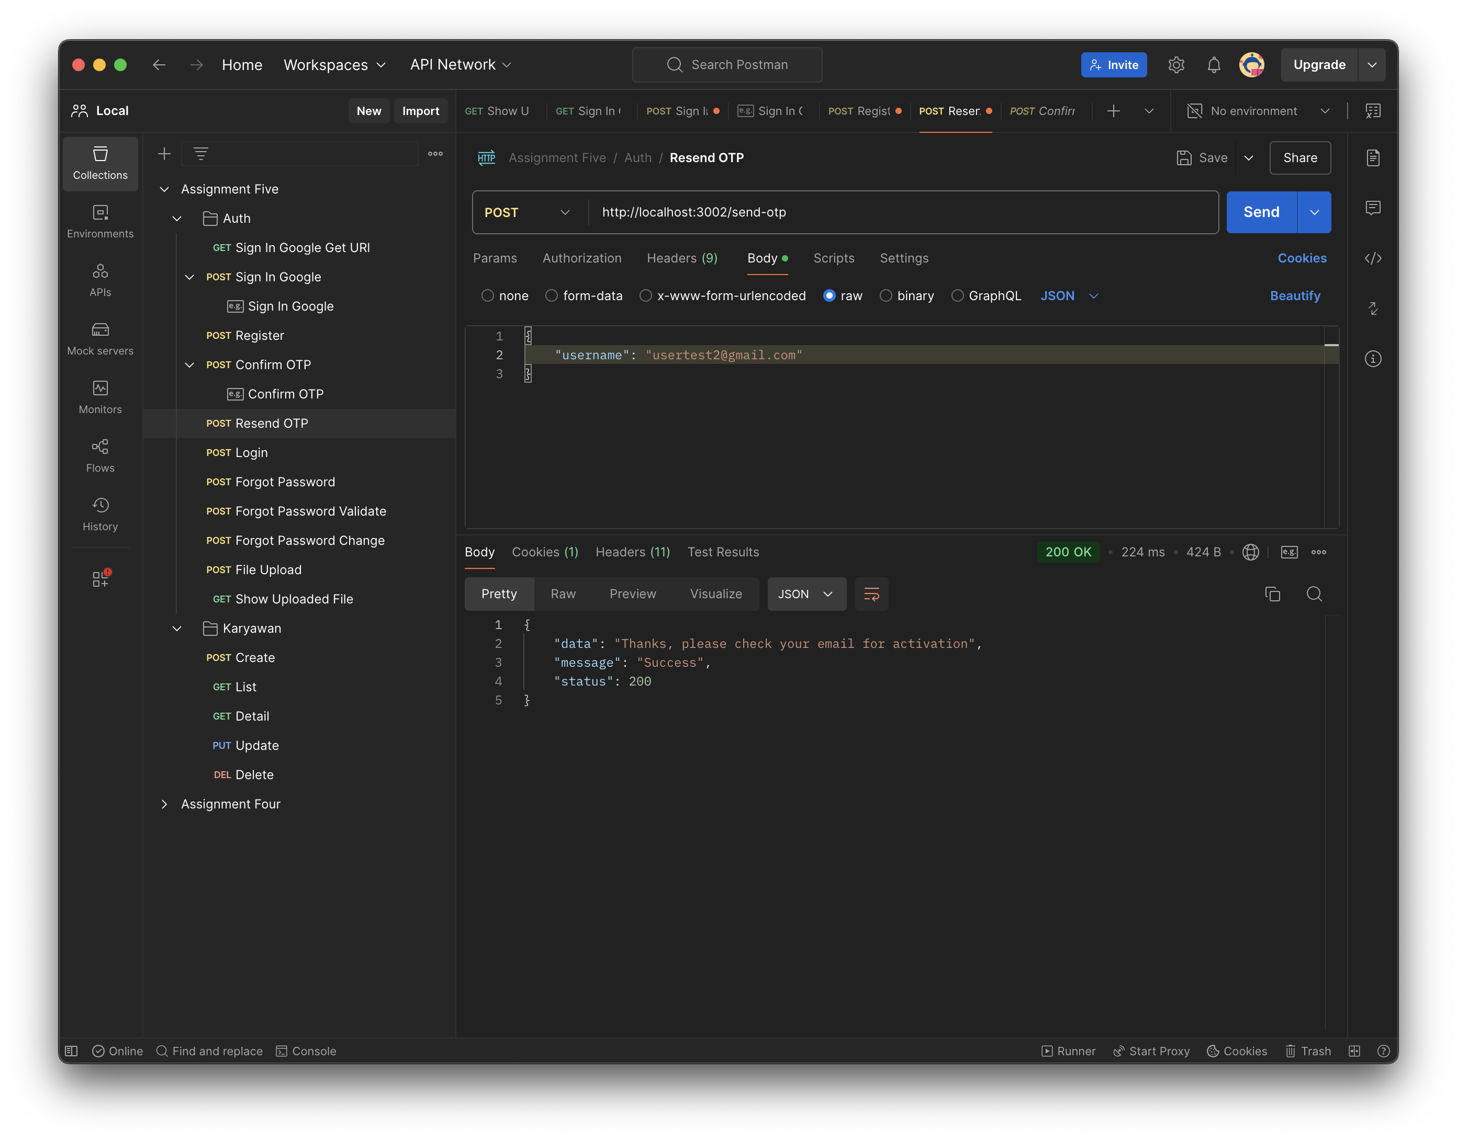  
      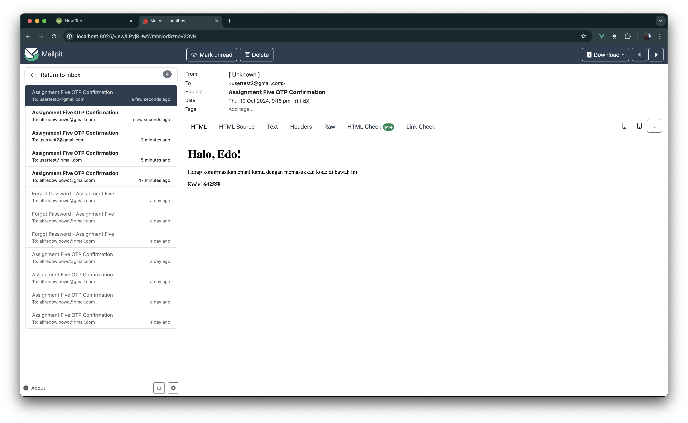  
        
        
        
        
        
        
        
        
        
        
        
        
        
        
        
        
        
        
        
        
        
        
        
      Endpoint Confirm OTP /register-confirm-otp/{otp}  
      Request Failed ­– Wrong OTP Code  
      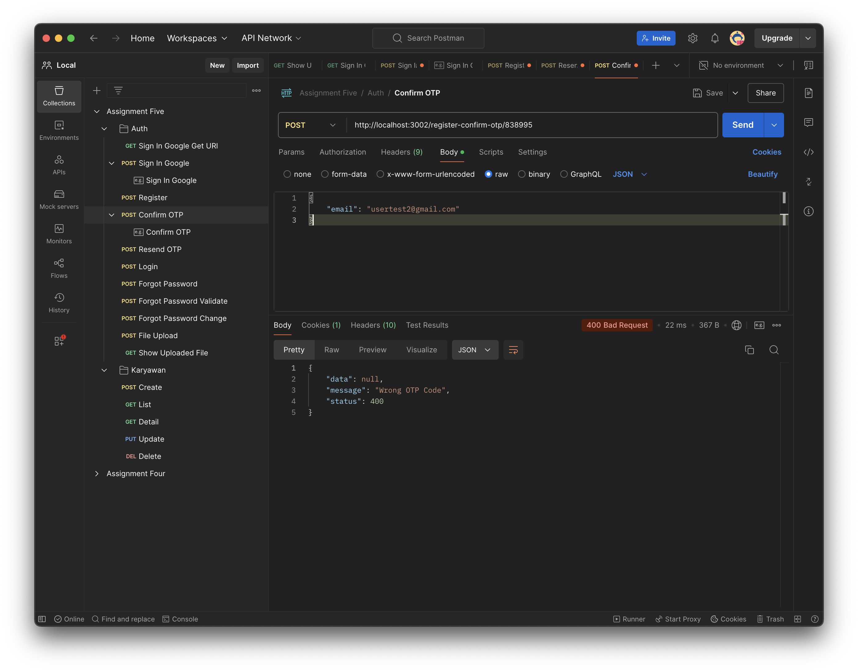  
      Request Success  
      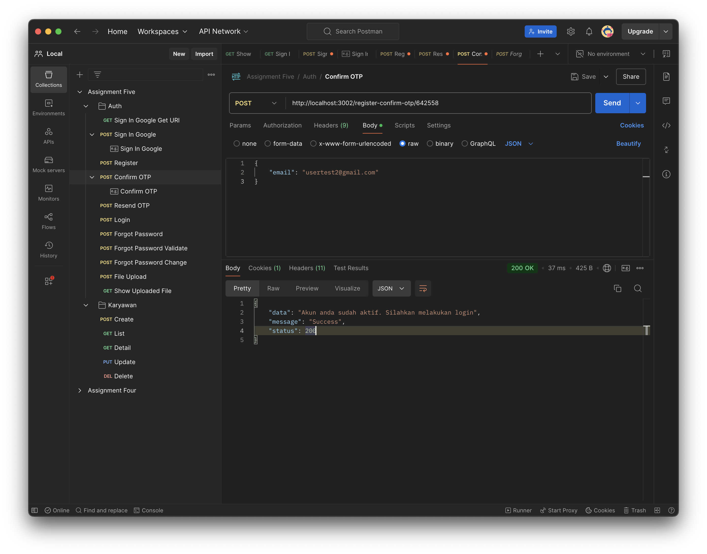
2. Rest API untuk Login  
   Endpoint /user-login/login  
     
   Request Success  
   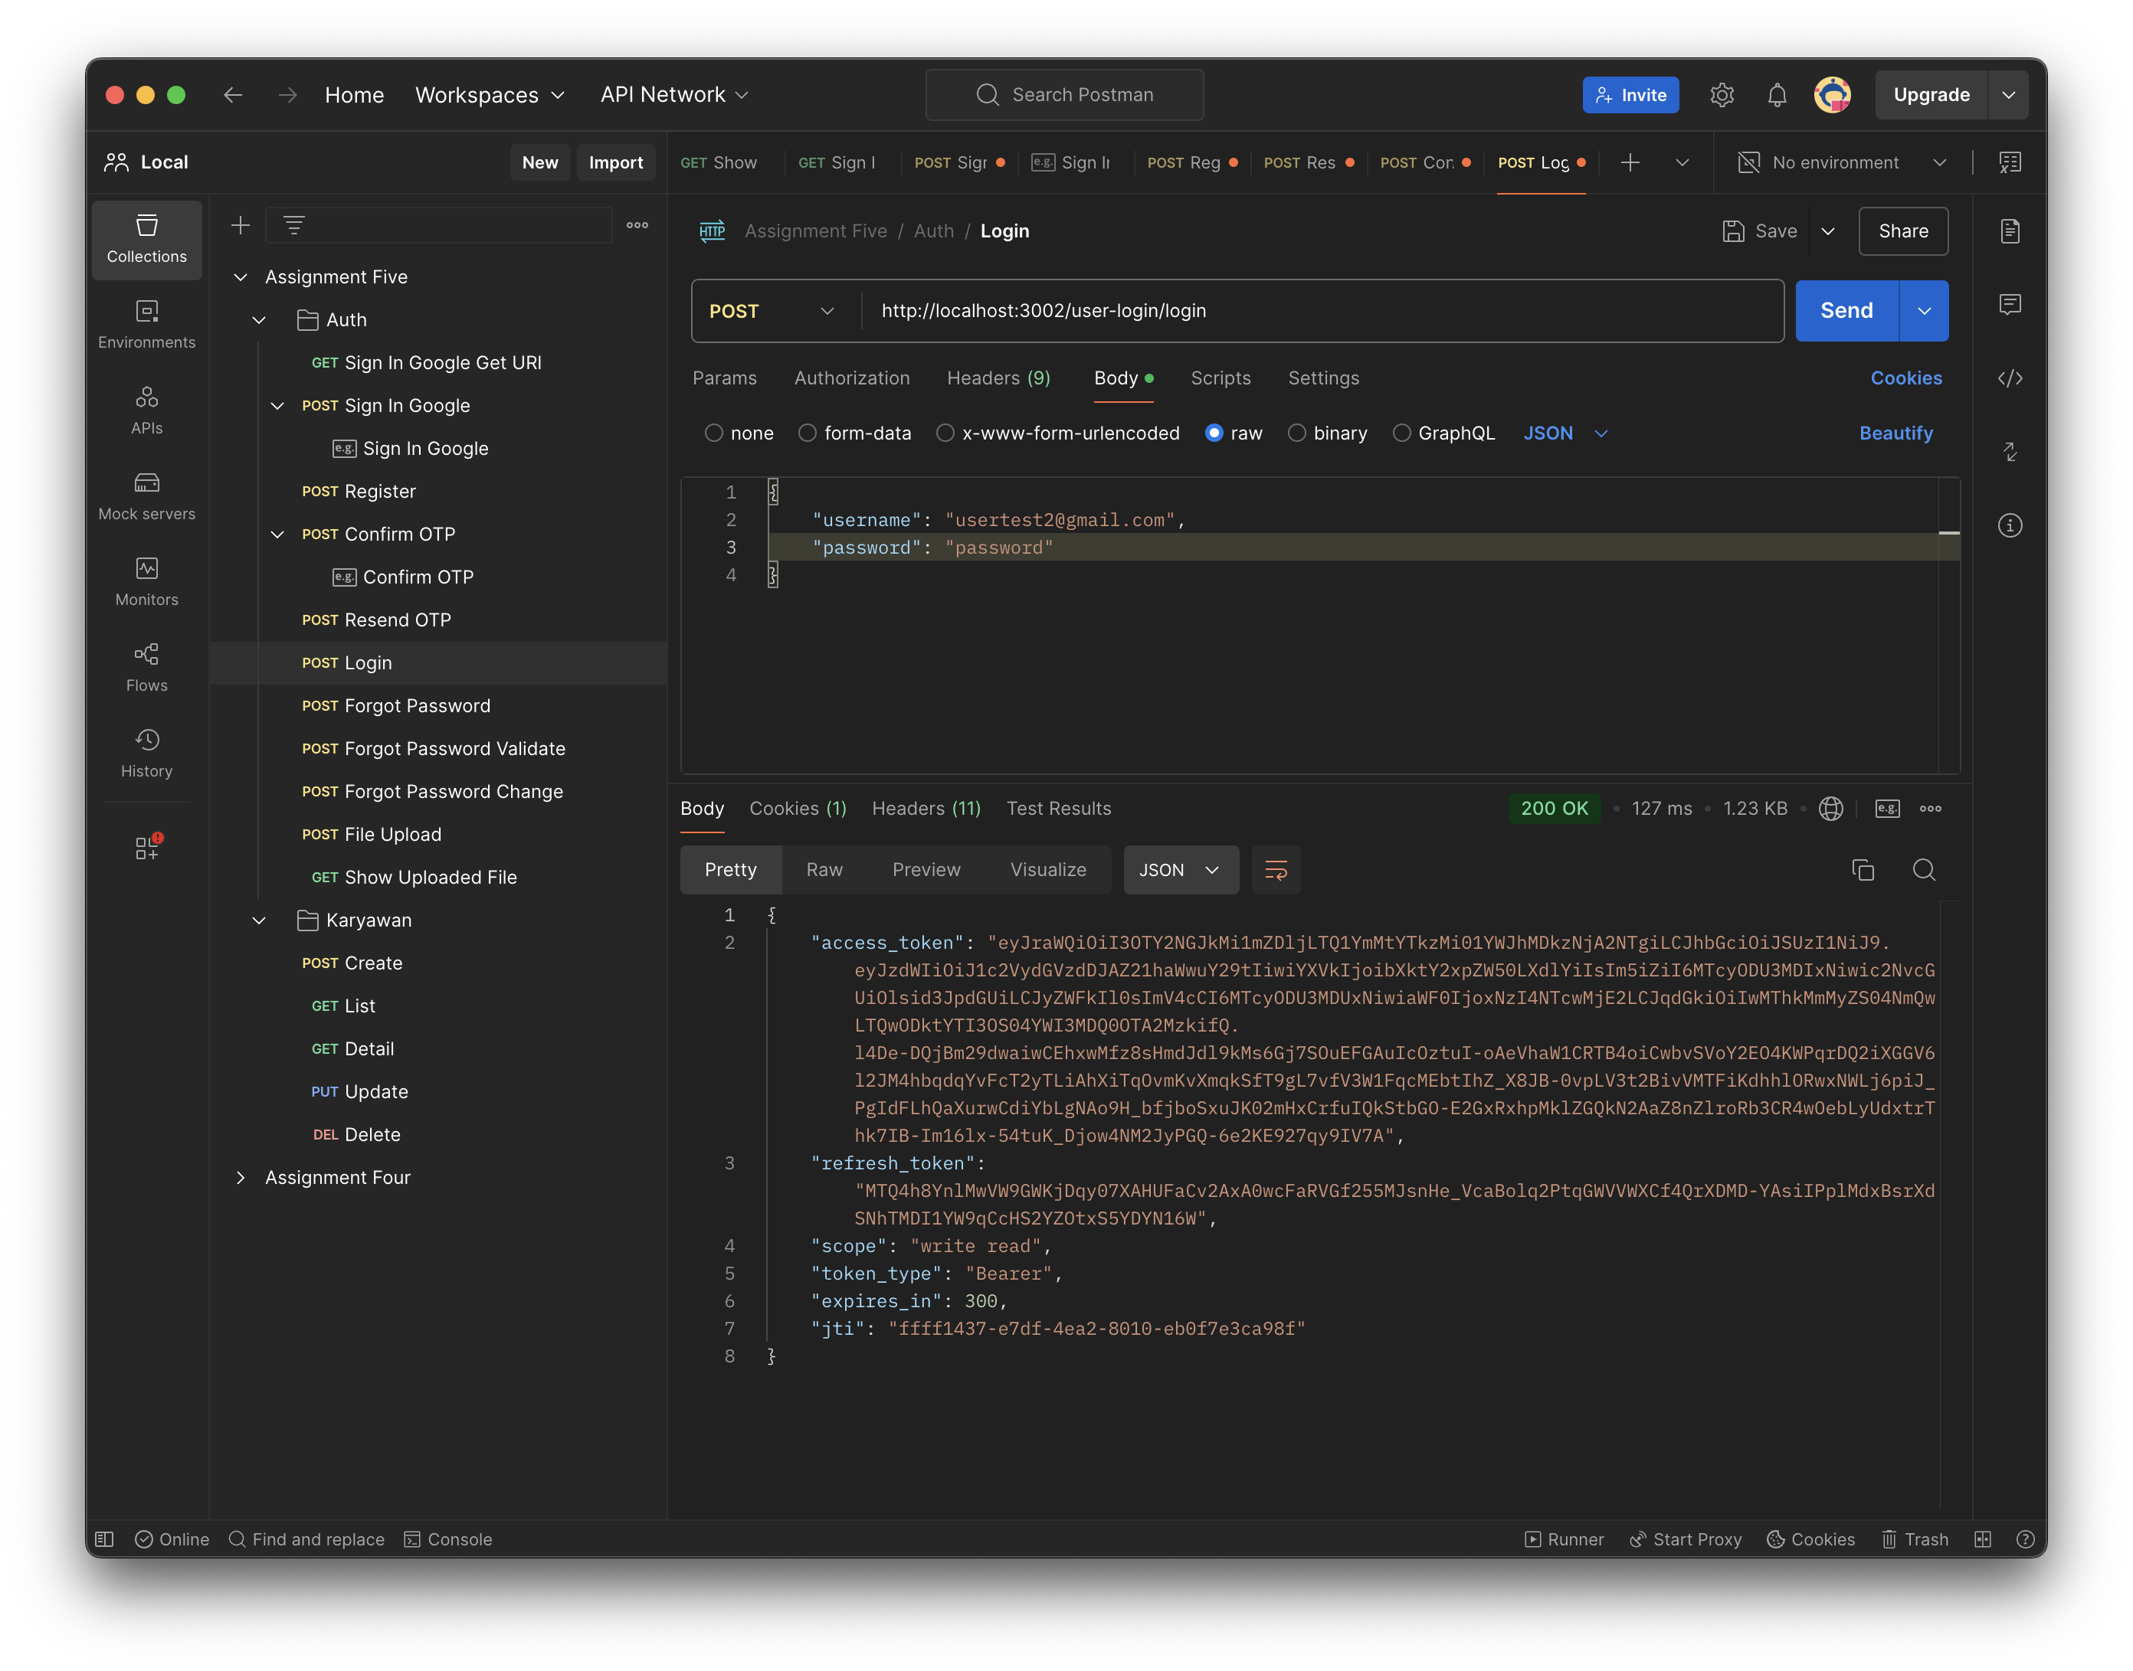  
   Request Failed  
   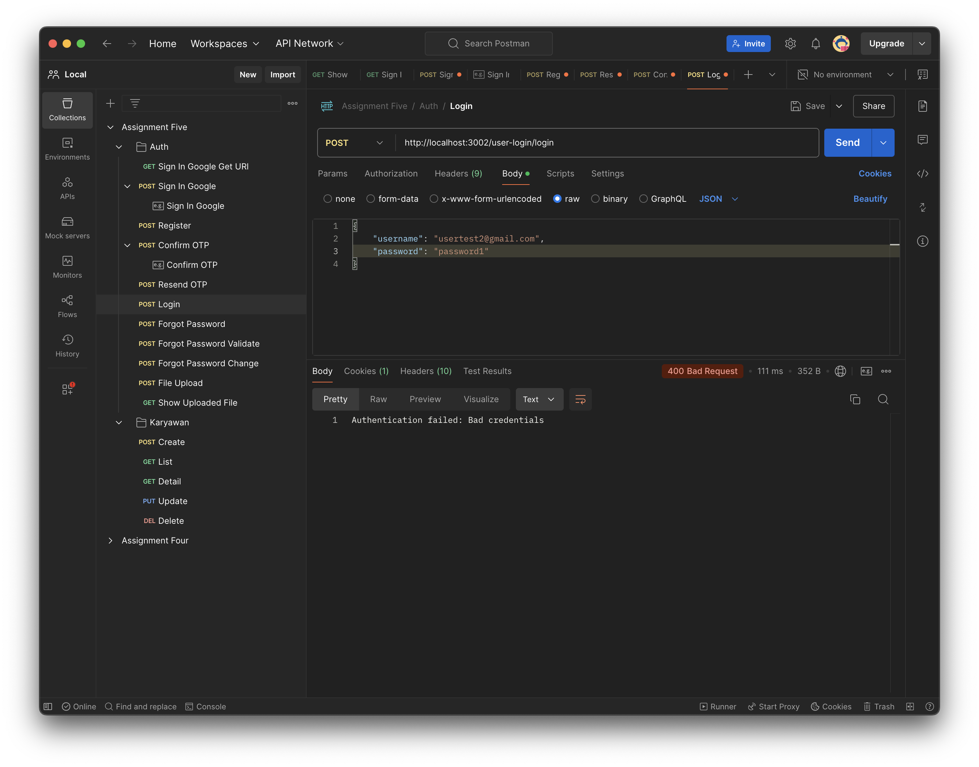
3. 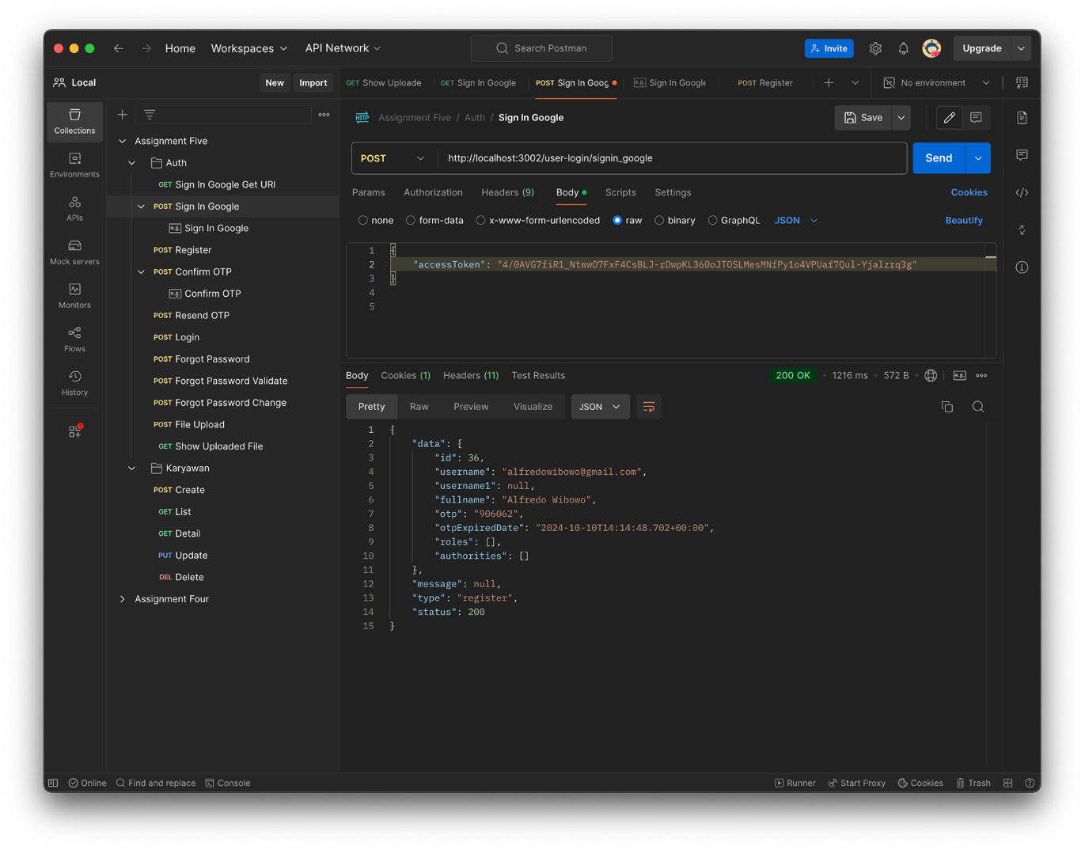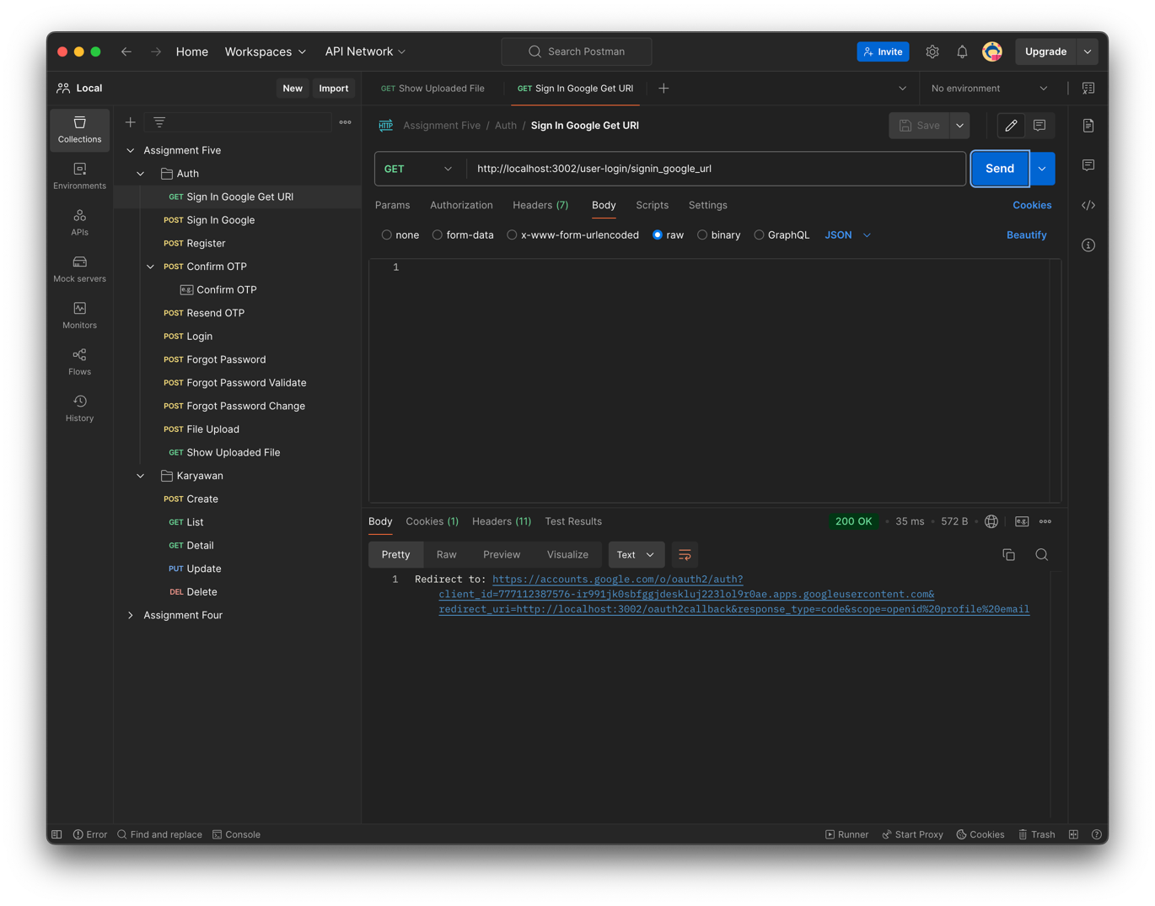Rest API Untuk Login By Oauth2.0 with Google  
   Endpoint: /user-login/signin_google_url  
     
   Endpoint:   
   /user-login/signin_google   
   type: “register”  
   type: “login”  
   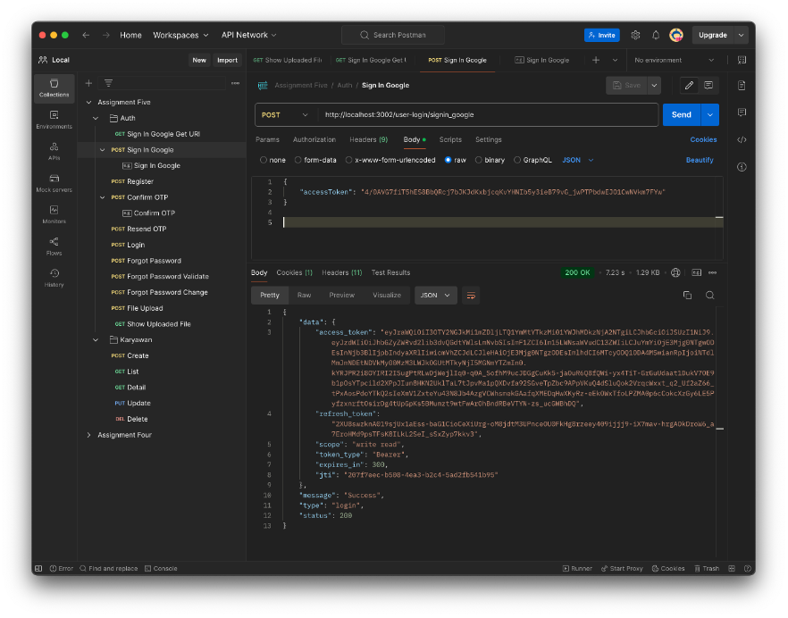
4. Rest API untuk forgot password  
     
   Endpoint /forgot-password/send  
   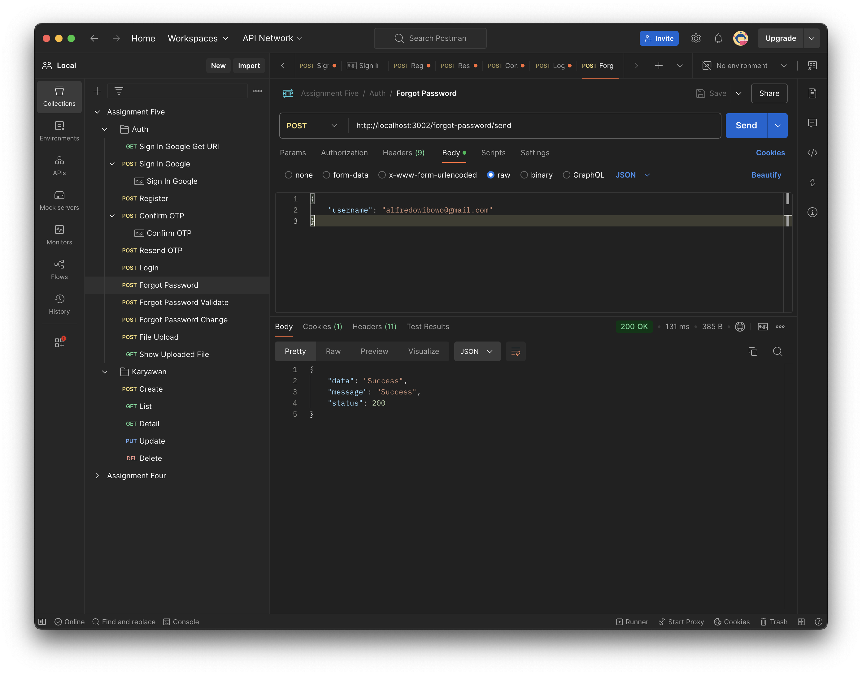  
   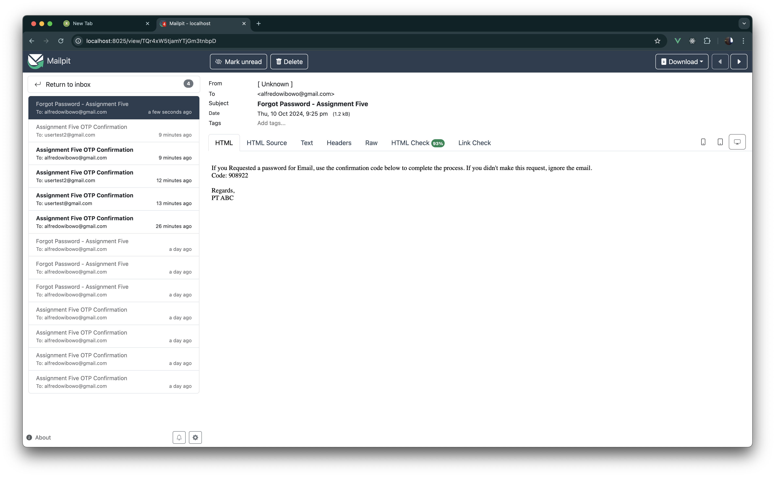  
     
     
     
     
     
     
     
     
     
     
     
     
     
     
   Validate Forgot Password OTP  
   Endpoint /forgot-password/validate  
     
   OTP Sesuai  
   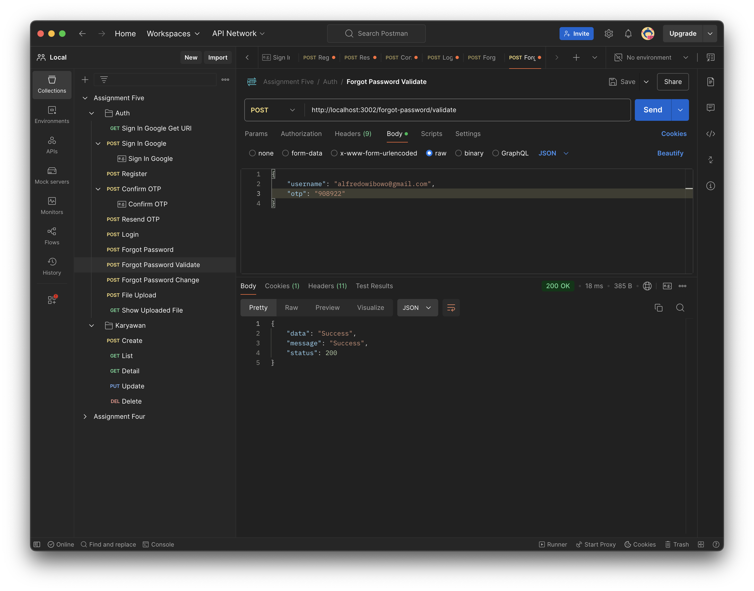  
   OTP tidak sesuai  
   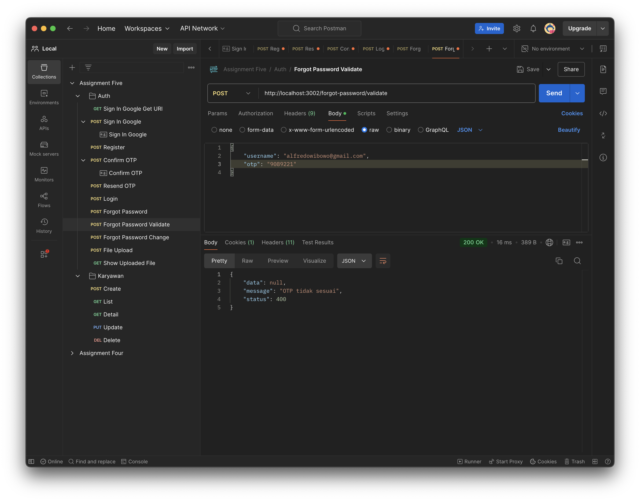  
   Email tidak ditemukan  
   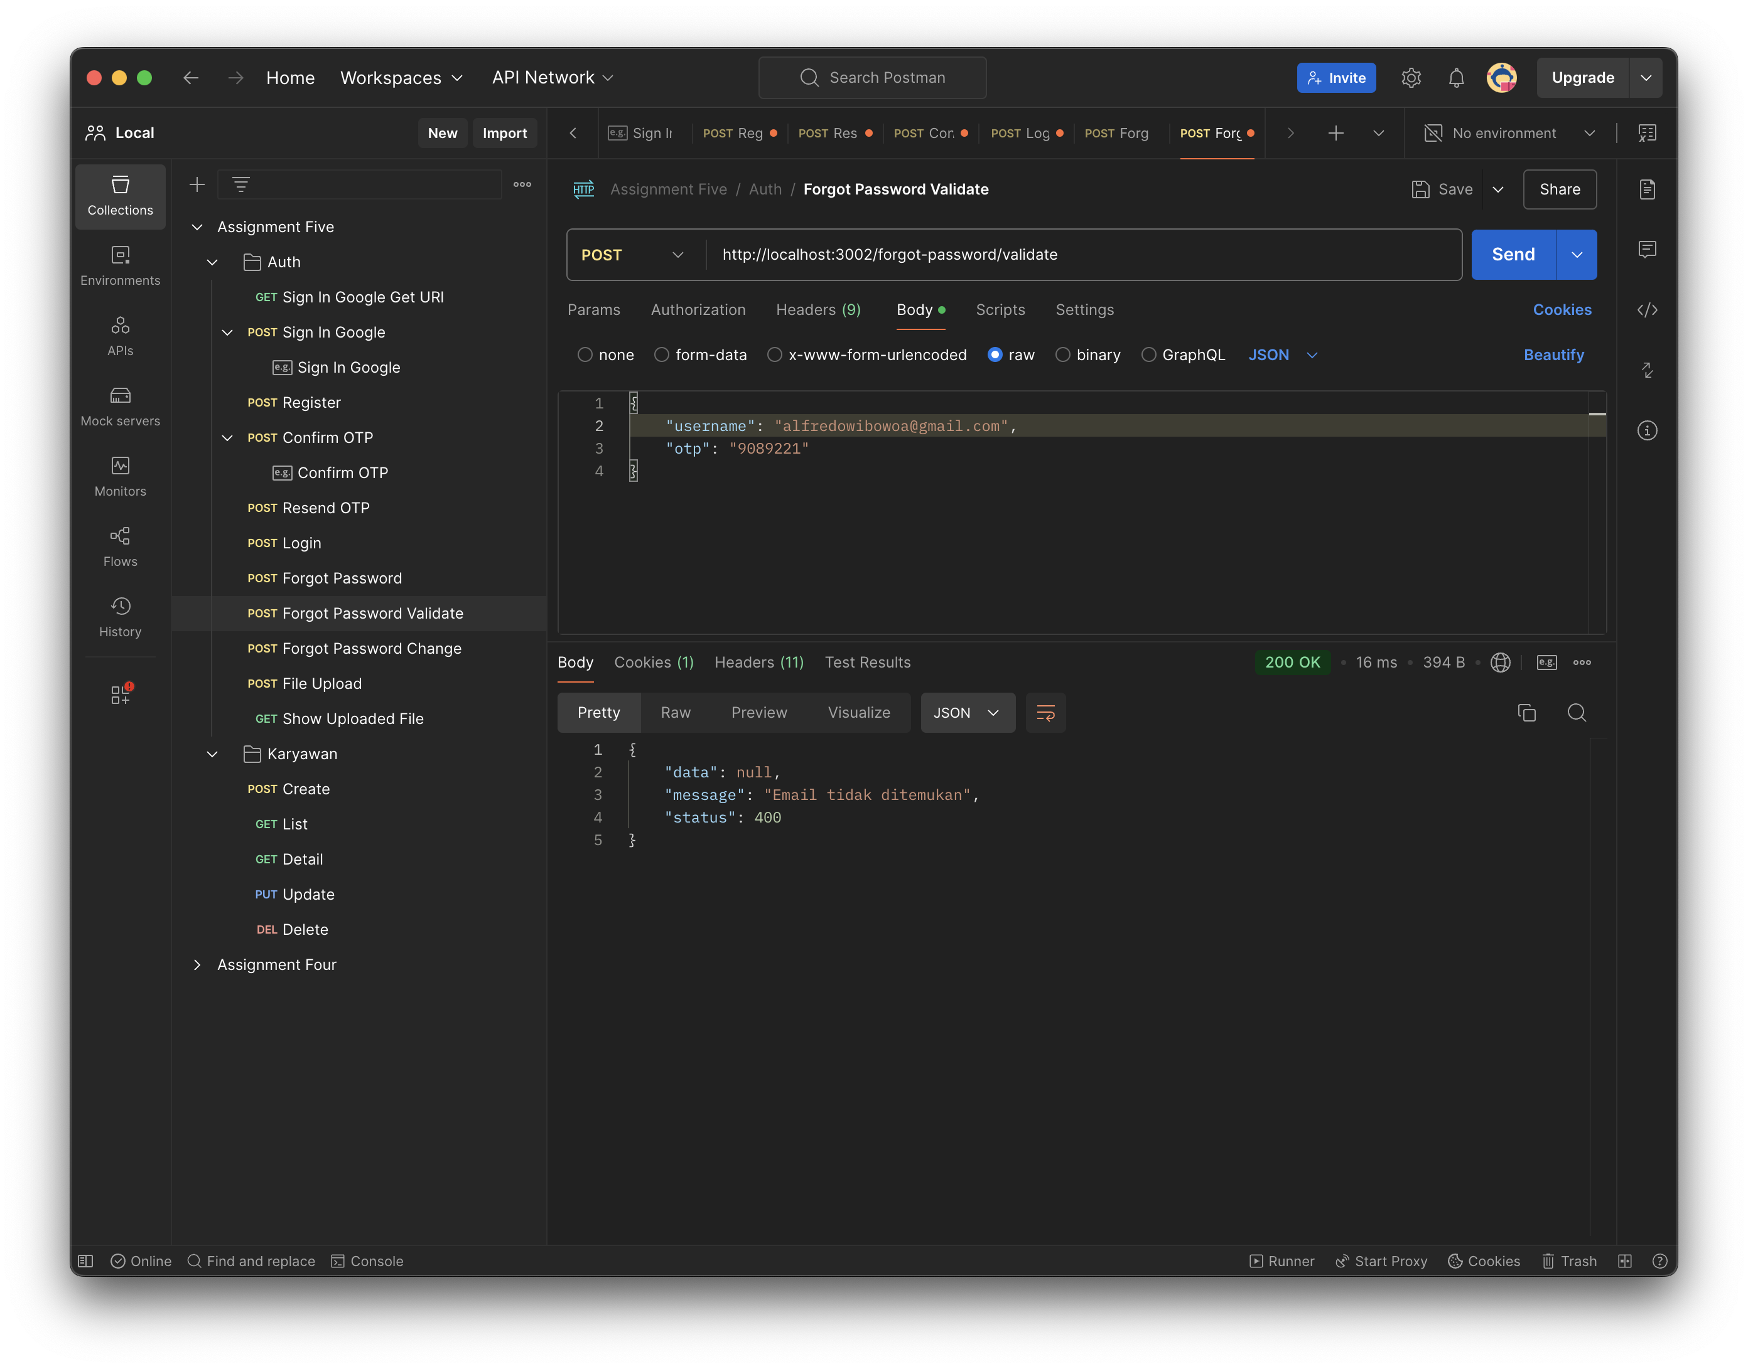  
   Change Password  
   Endpoint /forgot-password/change-password  
     
   Password Tidak Sesuai  
     
   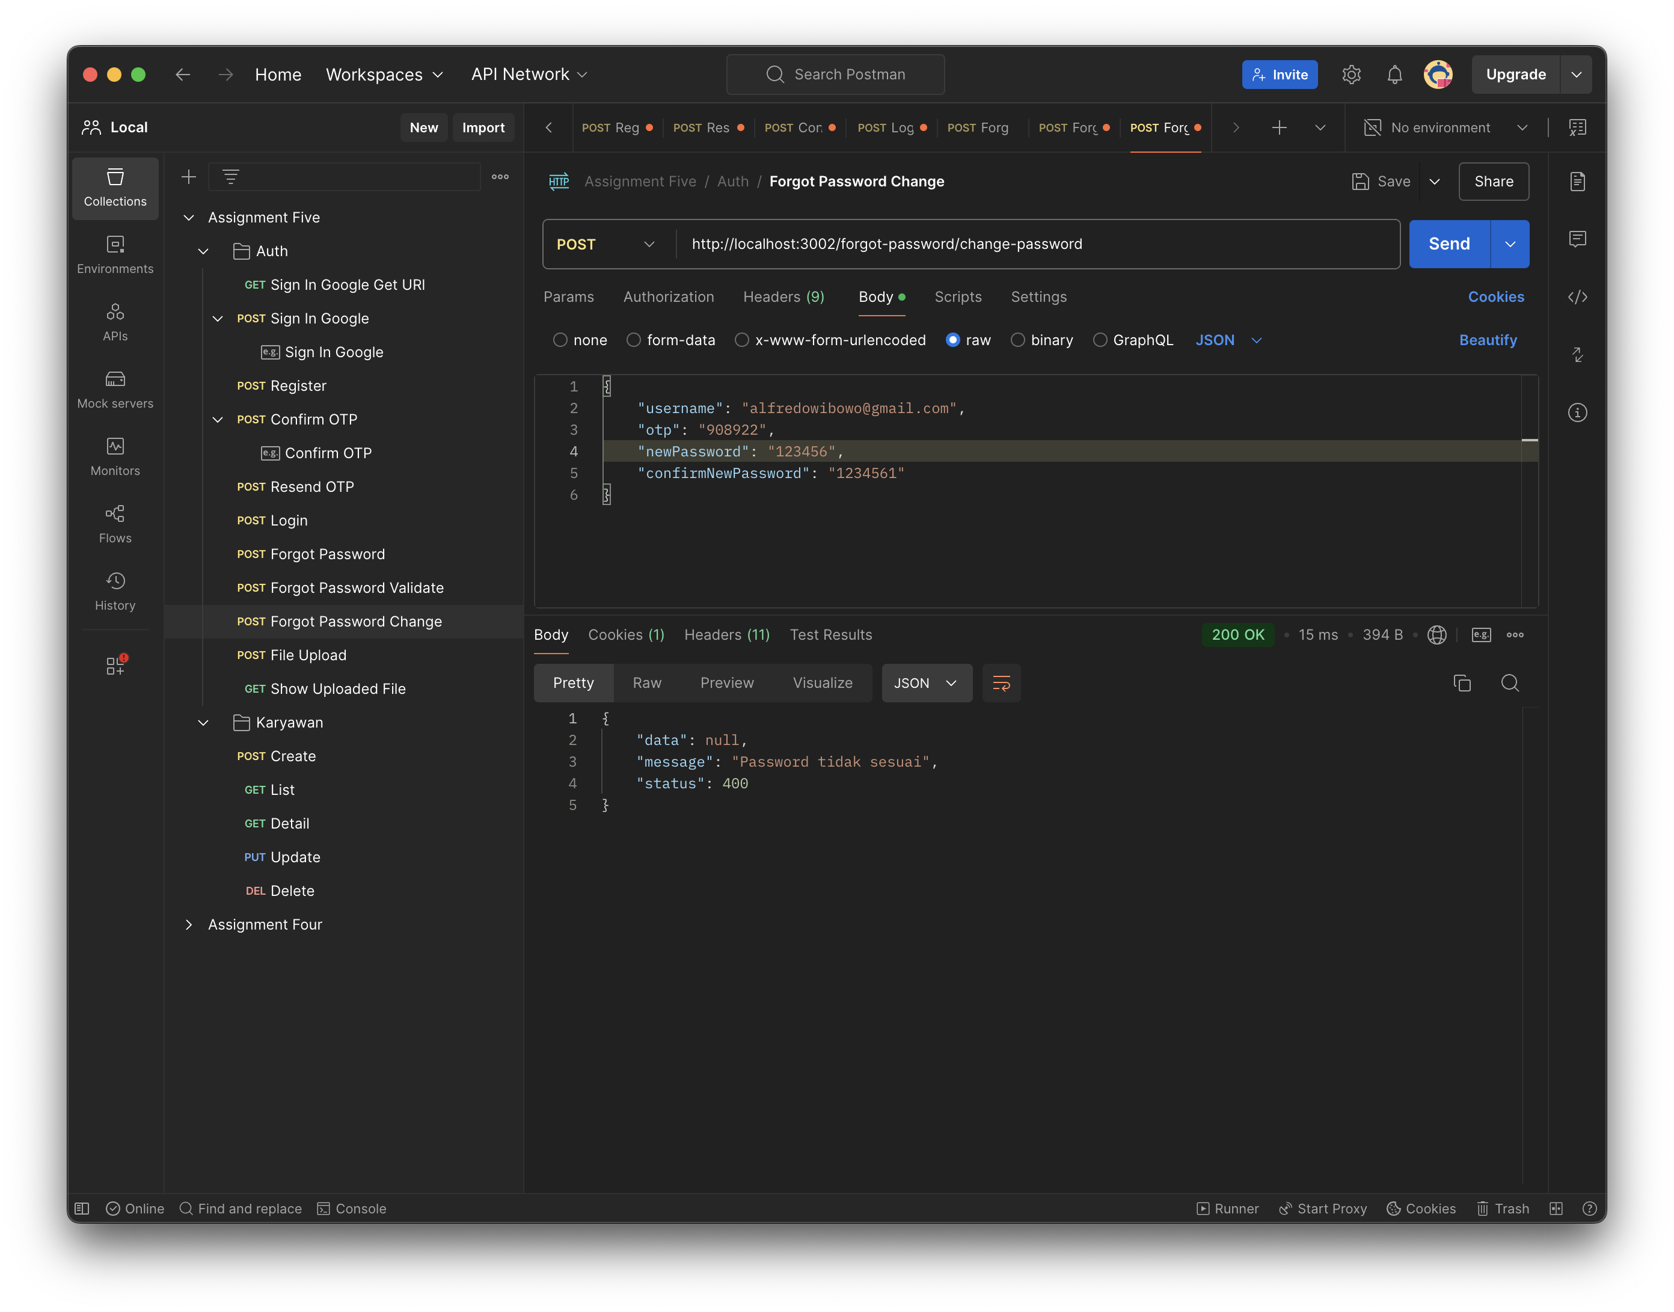  
   Success  
   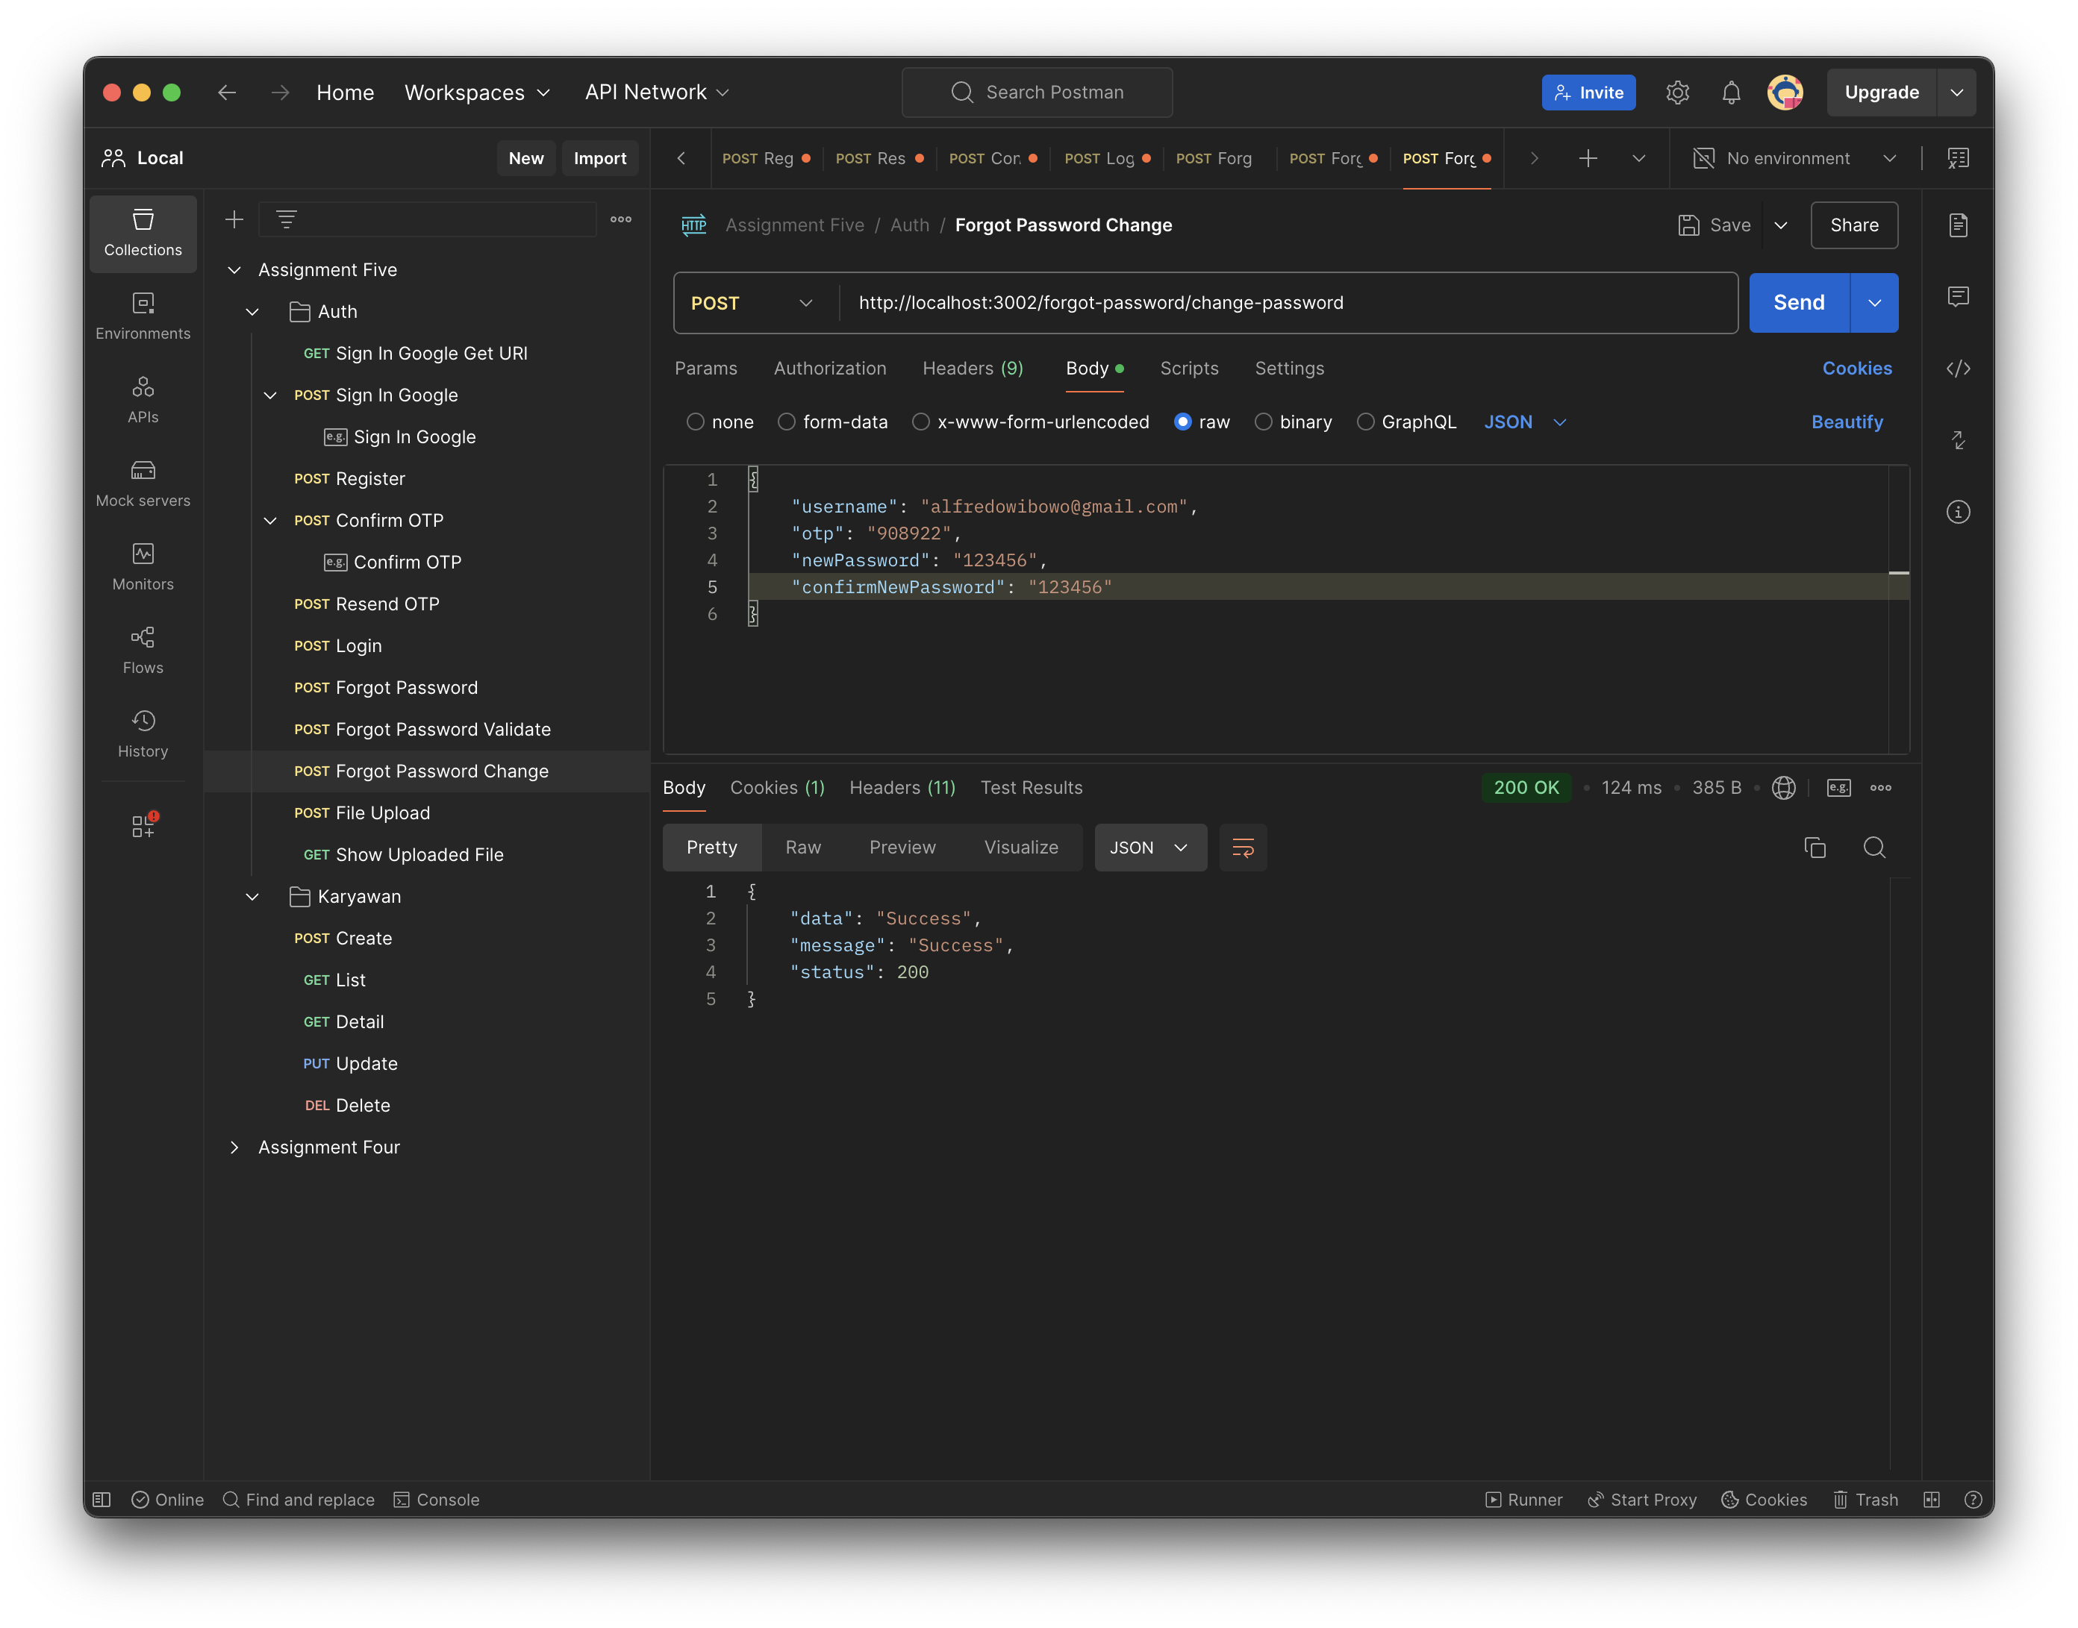
5. Rest API untuk upload file  
     
   Endpoint /v1/upload  
   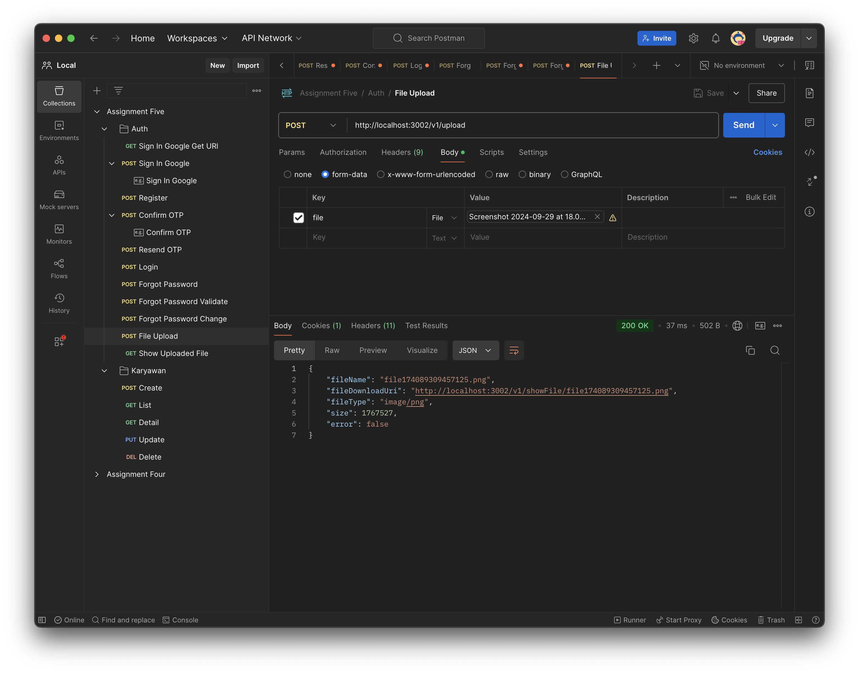  
   Endpoint show file  
   